

**Industrial Internship Report on**

**”Expense Tracker”**

**Prepared by**

**Khushi Jain**

|  |
| --- |
| *Executive Summary* |
| This report provides details of the Industrial Internship provided by upskill Campus and The IoT Academy in collaboration with Industrial Partner UniConverge Technologies Pvt Ltd (UCT).  This internship was focused on a project/problem statement provided by UCT. We had to finish the project including the report in 6 weeks’ time.  My project was Expense Tracker that allows a user to sign in and keep track of the expenses and income.  This internship gave me a very good opportunity to get exposure to Industrial problems and design/implement solution for that. It was an overall great experience to have this internship. |

**TABLE OF CONTENTS**

1 Preface 3

2 Introduction 4

2.1 About UniConverge Technologies Pvt Ltd 4

i. UCT IoT Platform 4

2.2 About upskill Campus (USC) 8

2.3 The IoT Academy 9

2.4 Objectives of this Internship program 9

2.5 Reference 9

2.6 Glossary 10

3 Problem Statement 11

4 Existing and Proposed solution 12

4.1 Code submission (Github link): 12

4.2 Report submission (Github link) : 12

5 Performance Test 13

5.1 Test Plan/ Test Cases: 13

5.2 Test Procedure: 13

5.3 Performance Outcome: 13

6 My learnings 14

7 Future work scope 15

# Preface

Summary of the whole 6 weeks’ work.:

It was a planned schedule where each work certain learning material was give and I had to complete it and submit weekly report accordingly.

About need of relevant Internship in career development.:

It is important to groom your skills and learn new technologies and build a project on it.

Brief about Your project/problem statement.:

User oriented project where they can login and use it for keeping track of their expenses and accordingly plan future endeavors.

Opportunity given by USC/UCT.

A great opportunity to learn and build simultaneously.

How Program was planned

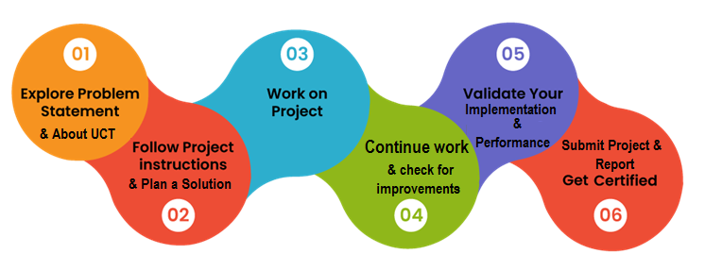

I learned about android development and was able to make project on it.

Thanks to the upskill campus team who constantly supported and guided throughout the project.

I would also encourage others to participate in such internship. It is a huge learning.

# Introduction

## About UniConverge Technologies Pvt Ltd

A company established in 2013 and working in Digital Transformation domain and providing Industrial solutions with prime focus on sustainability and RoI.

For developing its products and solutions it is leveraging various**Cutting Edge Technologies e.g. Internet of Things (IoT), Cyber Security, Cloud computing (AWS, Azure), Machine Learning, Communication Technologies (4G/5G/LoRaWAN), Java Full Stack, Python, Front end**etc.

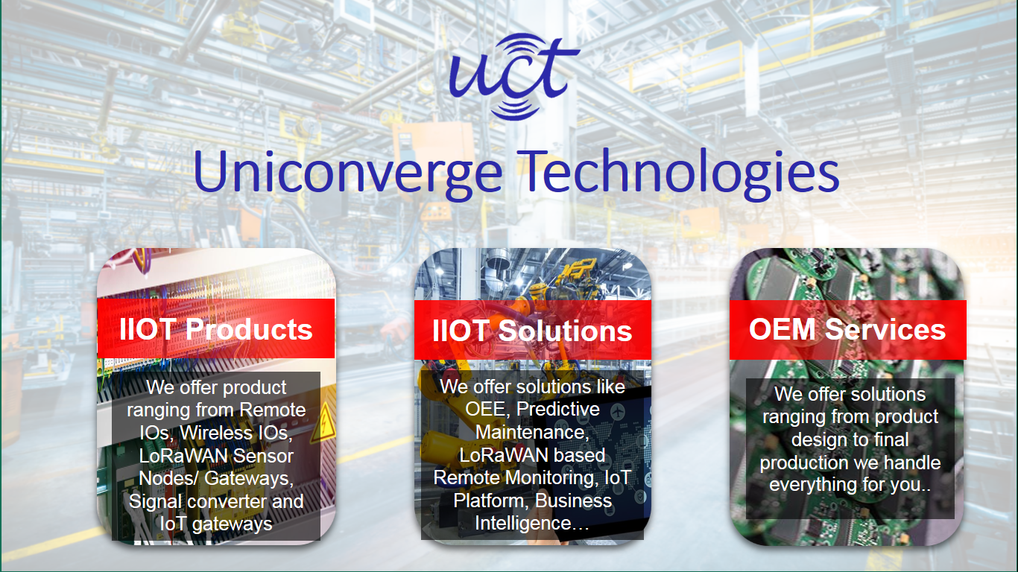

1. UCT IoT Platform **(****)**

**UCT Insight** is an IOT platform designed for quick deployment of IOT applications on the same time providing valuable “insight” for your process/business. It has been built in Java for backend and ReactJS for Front end. It has support for MySQL and various NoSql Databases.

* It enables device connectivity via industry standard IoT protocols - MQTT, CoAP, HTTP, Modbus TCP, OPC UA
* It supports both cloud and on-premises deployments.

It has features to  
• Build Your own dashboard  
• Analytics and Reporting  
• Alert and Notification  
• Integration with third party application(Power BI, SAP, ERP)  
• Rule Engine

 

1. **Smart Factory Platform (****)**

Factory watch is a platform for smart factory needs.

It provides Users/ Factory

* with a scalable solution for their Production and asset monitoring
* OEE and predictive maintenance solution scaling up to digital twin for your assets.
* to unleased the true potential of the data that their machines are generating and helps to identify the KPIs and also improve them.
* A modular architecture that allows users to choose the service that they what to start and then can scale to more complex solutions as per their demands.

Its unique SaaS model helps users to save time, cost and money.

 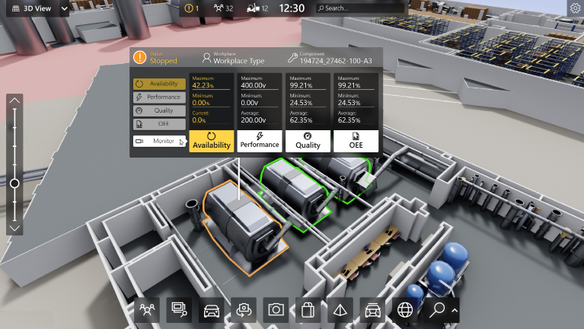

1. 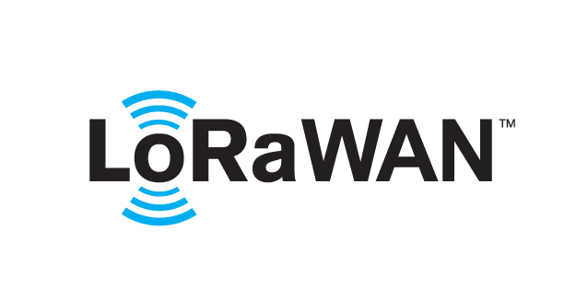 based Solution

UCT is one of the early adopters of LoRAWAN teschnology and providing solution in Agritech, Smart cities, Industrial Monitoring, Smart Street Light, Smart Water/ Gas/ Electricity metering solutions etc.

1. Predictive Maintenance

UCT is providing Industrial Machine health monitoring and Predictive maintenance solution leveraging Embedded system, Industrial IoT and Machine Learning Technologies by finding Remaining useful life time of various Machines used in production process.



## About upskill Campus (USC)

upskill Campus along with The IoT Academy and in association with Uniconverge technologies has facilitated the smooth execution of the complete internship process.

USC is a career development platform that delivers **personalized executive coaching** in a more affordable, scalable and measurable way.



Seeing need of upskilling in self paced manner along-with additional support services e.g. Internship, projects, interaction with Industry experts, Career growth Services

<https://www.upskillcampus.com/>

upSkill Campus aiming to upskill 1 million learners in next 5 year

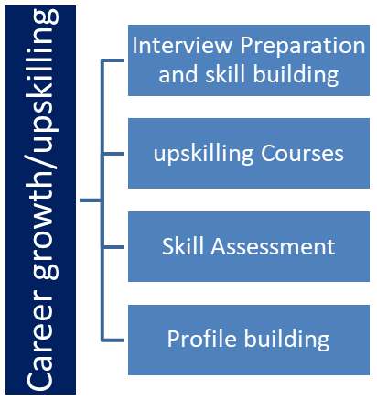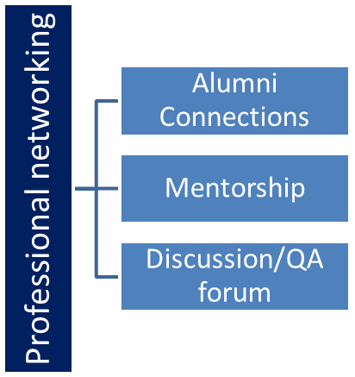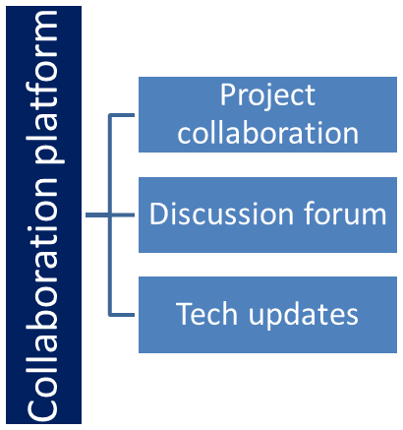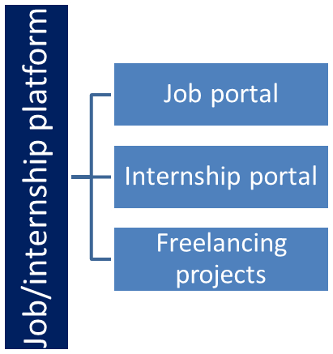

## The IoT Academy

The IoT academy is EdTech Division of UCT that is running long executive certification programs in collaboration with EICT Academy, IITK, IITR and IITG in multiple domains.

## Objectives of this Internship program

The objective for this internship program was to

 ☛ get practical experience of working in the industry.

 ☛ to solve real world problems.

 ☛ to have improved job prospects.

 ☛ to have Improved understanding of our field and its applications.

 ☛ to have Personal growth like better communication and problem solving.

## Reference

[1] https://learn.upskillcampus.com/

[2] https://firebase.google.com/

[3] https://developer.android.com/

## Glossary

|  |  |
| --- | --- |
| Terms | Acronym |
| UCT | Uniconverge Technology |
| IoT | Internet of Things |

# Problem Statement

In the assigned problem statement

* It is an app where the user will log in anonymously and will be able to enter the data according to the expenses and income of the month.
* The app will calculate the ratio of expenses and income and accordingly display the pie chart for the user to check and evaluate the expenses and accordingly plan the next month endeavors.

# Existing and Proposed solution

The people could have used a simple diary or pen and paper to write their daily expenses but however they won’t be able to compare it with the previous data.

What is your proposed solution?

My proposed solution is that :

* I have made an app where the user will sign in anonymously
* Enter the data
* Pie chart showing the comparisons would be generated.

What value addition are you planning?

* I am planning to add some extra features like instead of anonymous authentication I will allow users to sign in through a finger lock.
* I also want to add some extra features like past activity etc.

## Code submission (Github link):

<https://github.com/to-program-khushi-jain/upskill_campus/tree/master>

## Report submission (Github link) :

<https://github.com/to-program-khushi-jain/upskill_campus/tree/master/Final_InternshipReport_USC_UCT>

# Performance Test

## Test Plan/ Test Cases:

* Clicking on expense and adding the expense.
* Same for income and test by editing entry and seeing the noticeable change in the pie chart.

## Test Procedure:

* Select add income
* Add income and type category and amount .
* Click save
* Do same for add expense
* Below the pie chart area see if the entry is added after you save the entry
* See accordingly the pie chart is updated or not.
* Click an entry and check if the entry could be edited or not.

## Performance Outcome:

* After adding all the data the pie chart is created accordingly.
* The user could sea and analyse the expenses made so far and plan for the future endeavors.

# My learnings

I learned the following:

* I learned time management.
* I learned android .
* I get to know about firebase .
* I gained confidence and got motivated for more such opportunity in the future.

# Future work scope

* I am planning to add some extra features like instead of anonymous authentication I will allow users to sign in through a finger lock.
* I also want to add some extra features like past activity etc.